Cal Employee Connect (CEC) – Paycheck Calculator Feature

Navigation

- Visit https://connect.sco.ca.gov/login

- Login to your personal CEC account

- From the CEC home page select the ‘Earnings’ tab

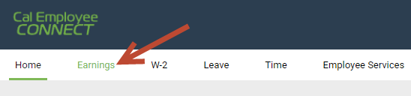

- Select your monthly Earnings Statement (note: this feature is only accurate for the current tax period)

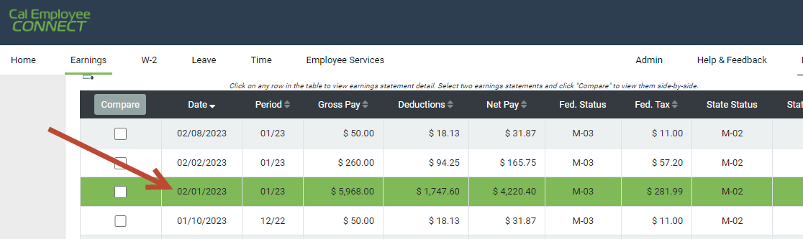

- Select ‘Paycheck Calculator’ and calculate away

